Medical Plan
2019 Athlete Acceleration Summit

Medical Plan

Medical situations may arise at any time during athletic events. Expedient action must be taken in order to provide the best possible care to the sport participant in an emergency situation. This plan is designed to help ensure that the best care will be provided.
Despite the best training and preparation, accidents and injuries are inherent with sports participation. As emergencies may occur at any time and during any activity, the medical staff and related personnel must be prepared. While we hope it will not be needed, this plan outlines the medical coverage, emergency supplies and equipment and emergency communication necessary to provide appropriate care to an ill or injured participant during the 2019 Athlete Acceleration Summit.

Components of the Medical Plan

The following information is included in this plan.
- On-site medical personnel
- Emergency medical system communication
- Supplies and equipment
- Emergency evacuation plan for non-medical emergency
- Directions and map to hospital and local urgent care

On-site Medical Personnel
There will be on-site medical personnel stationed on site for all scheduled on-ice ATHLETE ACCELERATION programming.

The medical personnel schedule is as follows. **add in double duty for each rink!!
Date | Title | Name | Cell Phone | SafeSport/Check | Times | Location
Fri., April 26th | MD | Chris D. | 555-555-5555 | Complete | 2:00 – 5:30 pm | Rink D
Sat., April 27th | ATC | Rudy A. | 555-555-5555 | Complete | 7:00 am – 1:00 pm | Rink D
Sun., April 28th | PT | Bob C. | 555-555-5555 | Complete | 11:00 am – 3:00 pm | Rink D

Note: Sarah T. (PT) is currently non-compliant (background check in progress), will support 11:00 am to 3:00 pm if complete in time.

As always, call 911 in case of emergency.

Role of Medical Volunteer – Non-emergency

Assess the injury / illness

Athletes reporting with complaints of injury / illness should be interviewed regarding symptoms and assessed to determine the need for emergency medical assistance vs. basic first aid. If emergency medical assistance is required, use the information on page 4 to contact Emergency Medical Services.

Provide basic first aid

On-site medical personnel can provide basic first aid, such as:

Ice a minor injury

Bandage a cut

Provide over the counter analgesic for headache/other minor reports of pain

Contact a parent to pick up an athlete who is not well, but does not require Emergency Medical Services

Document incident

Using the U.S. Figure Skating Incident Report, document any medical contact and response.

Role of Medical Volunteer – Emergency

- Establish scene safety and immediate care of the athlete
The first and most important role is establishing safety of the scene and immediate care of the athlete. Acute care in an emergency situation should be provided by the most qualified individual on the scene. Individuals with lower credentials should yield to those with more appropriate training.
- Call Emergency Medical Services (i.e. 911)
Emergency Medical Services activation may be necessary in situations where emergency transportation or treatment is required. This should be done as soon as the situation is deemed an emergency or a life-threatening event. Time is the most critical factor under emergency conditions. Activating the Emergency Medical Services system may be done or directed by the medical personnel on duty.
- Emergency equipment retrieval
All medical equipment and supplies will be available in the medical room. If the injured athlete cannot be moved, the medical volunteer will bring supplies and equipment to the scene of the injury.
- Direct Emergency Medical Services to scene
Once Emergency Medical Services has been called the medical volunteer will assign someone to the role of directing them to the scene.

Emergency Medical Services Communication

Activating the Emergency Medical Services System - Making the Call:
- 911 is the emergency phone number for Irvine
- Additional telephone numbers for police and fire department are as follows.
  - Local Police 555-555-5555
  - Local Fire Station 555-555-5555

Supplies and Equipment
The medical supply bag is our standard PT kit that contains basic bandages, wraps, etc. and some basic OTC medication. The medication should only be dispensed by RN, PA, or physicians. The following supplies and equipment will be available in the medical kit or where indicated and should be brought to the scene of an injury, if needed.

- First Aid kit located behind the desk, which includes
  - Ice bags/access to ice
  - Bandaids of various sizes
  - Aleve/Ibuprofen
  - Med wrap
  - alcohol wipes
- AED
  - Locate in the facility!
- Additional supplies in the medical kit
  - 4 x 4 gauze
  - Surgical tape
  - Elastic bandages
  - Exam gloves
  - Antiseptic wipes
  - Blister bandaids
- Forms and Documents
  - A copy of this Emergency Medical Plan
  - Emergency contact information for all camp attendees
  - Reported allergy / medical condition information
  - Medical room visit / response report forms
  - Directions to local medical facilities

Emergency Care and First Aid Procedures
Directions and map to hospital and local urgent care
The closest hospital/urgent care is Hoag Health Center Irvine - Sand Canyon.

16200 Sand Canyon Ave
Irvine, CA 92618
(800) 400-4624

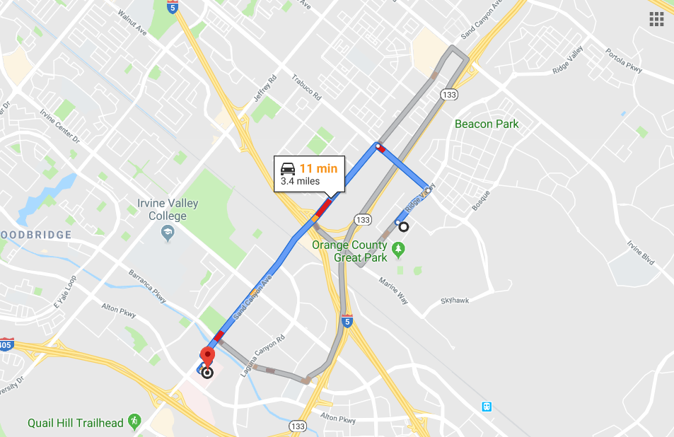

Based on the Sample Emergency Action Plan provided by Sports Medicine International.

